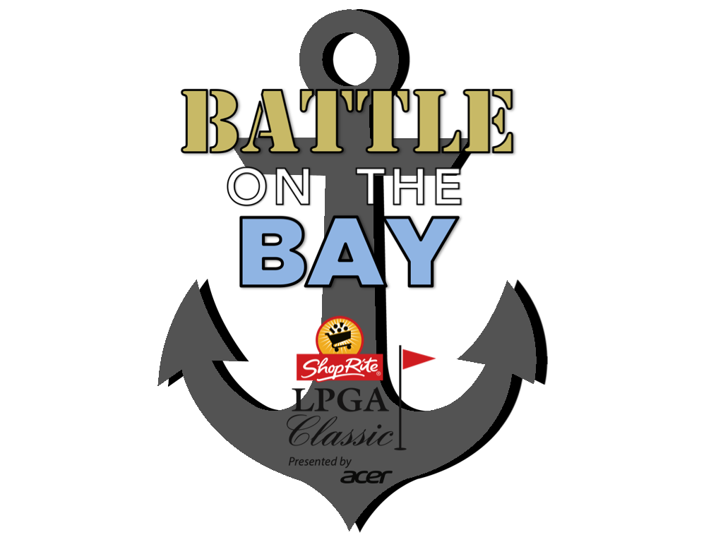
Battle on the Bay – Am Qualifier

Sunday, July 26th, 2020
Seaview, A Dolce Hotel, Bay Course
401 S. New York Road
Galloway, NJ 08205

Eligibility: Female amateur golfer with a USGA handicap index of 2.0 or less.

Start Time: 10:00 a.m.

Format: Stroke play; low score will be crowned Battle on the Bay winner and earn a playing spot in the Official LPGA qualifier on Monday, July 27th, 2020 at 1 p.m. on the Tournament Course, Seaview, A Dolce Hotel, Bay Course. In the event of a tie, winner will be determined by match of cards, using USGA rules.

Local Tournament Rule: Laser guides ARE PERMITTED as pin location sheets may not be available, but ARE NOT allowed in the Monday Pro-Qualifier

Fee: $50 (fee will be refunded or applied to the $230 Monday qualifier fee for the winner); check or money order only

Payments: Via check made out to Eiger Marketing Group by Friday, July 24th at 5 p.m. EST. Can be mailed to the office – Eiger Marketing Group, Attn: Nicole Cote, 165 W. Putnam Avenue, Greenwich, CT 06830

Entry Deadline: Friday, July 24th at 5 p.m., EST

Entry Instructions: Please contact Nicole Cote via e-mail ncote@eigermarketing.com to confirm participation

Practice Rounds: Practice rounds can be arranged by calling Tyler Teynor, Golf Professional, at 609-748-7682.

Directions to Seaview

From Atlantic City Expressway:
Take the Atlantic City Expressway to Exit 7N, the Garden State Parkway (GSP) north. Follow the GSP north and take exit 41 (Pomona / Galloway). Make a right at the light onto Jimmie Leeds Road and follow east for approximately five miles to Route 9. At the traffic light, turn right onto Route 9 and Seaview will be on your immediate right.

From Garden State Parkway:
Take exit 41 (Pomona/Galloway) of the Garden State Parkway to Jimmie Leeds Road. Go east on Jimmie Leeds Road for approximately five miles to Route 9. At the traffic light, turn right onto Route 9 and Seaview will be on your immediate right.

From Route 206 – SOUTHBOUND
Route 206 to Route 30 in Hammonton. Proceed eastbound on RT 30 approximately 20 miles to New Road. Turn left at New Road. At five-way traffic light, continue straight onto New Road/Wyoming Avenue. Turn left at US-9 North/Shore Road. Drive 1.4 miles and Seaview will be on your left.

From Route 40 – EASTBOUND
Route 40 eastbound to Route 322 (Hamilton Mall). Proceed right on RT 322/RT 40 and follow for about 7 miles. Turn left at US-9 North/New Road. Drive about 3 miles. At five-way traffic light, continue straight onto New Road/Wyoming Avenue. Turn left at US-9 North/Shore Road. Drive 1.4 miles and Seaview will be on your left.

2020 Battle on the Bay - Amateur Qualifier - Applicant Form

Name:__________________________________________________________________________

Address:________________________________________________________________________

Telephone:________________________________

Email Address:___________________________________________________________________

Handicap Verification

Current USGA Handicap Index:______

Verified By:______________________________________________________________________
(Club Official Name and Title – Please Print)

Clubs Signature: _________________________________________________________________

Name of Club: ___________________________________________________________________

Club Contact Number: _____________________

Signature of Applicant:____________________________________________________________

Date:______________

*Certification of Parent or Guardian (for minor only)

As a parent or guardian of the above applicant, I am familiar with her plans to participate in the 2020 ShopRite
LPGA Classic Presented by Acer Battle on the Bay - Amateur Qualifier and that she does have my approval.

Signature:________________________________________________________________________

Date:_______________

